|  |  |
| --- | --- |
| Source Id | URL |
| 300364899 | <https://jgo.amegroups.org/#current-issue> |
| 300635099 | https://jtd.amegroups.org/#current-issue |
| 346239599 | https://tau.amegroups.org/#current-issue |
| 641122728 | https://tcr.amegroups.org/#current-issue |
| 643108427 | https://cco.amegroups.org/#current-issue |
| 643108428 | https://tlcr.amegroups.org/#current-issue |
| 652350925 | https://atm.amegroups.org/#current-issue |
| 652350926 | https://cdt.amegroups.org/#current-issue |
| 652350929 | https://qims.amegroups.org/#current-issue |

Kindly note above source websites has same structure.

1)Go to the website using base URL so you will be direct to current issue page like below



2)Capture article title from here

3)Capture page range from here

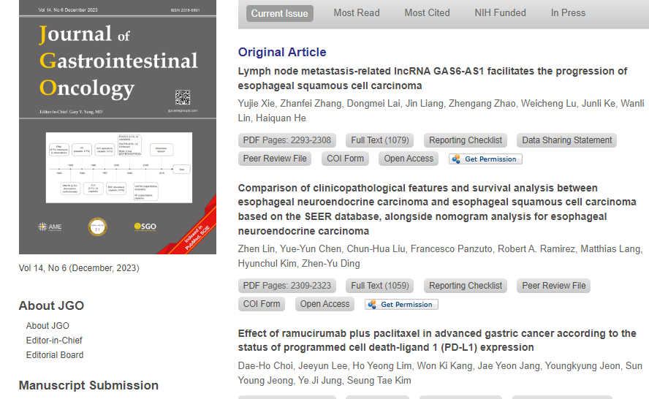

**5)Capture Volume**

**4)Capture Issue**

**7)Capture Year**

**6) Capture Month**

**8)Click Article Name**

You will direct to article page after clicking article name



**9)Capture doi from here**

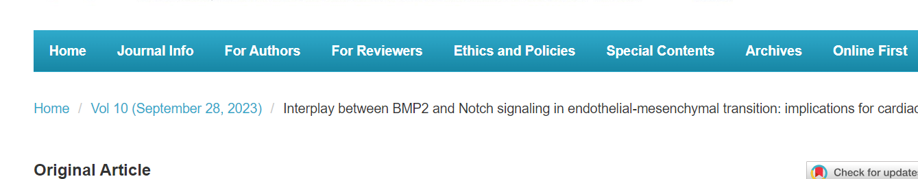

**10)Capture publication date form here**

**11)Click here to download pdf**

**Then click here to download pdf**